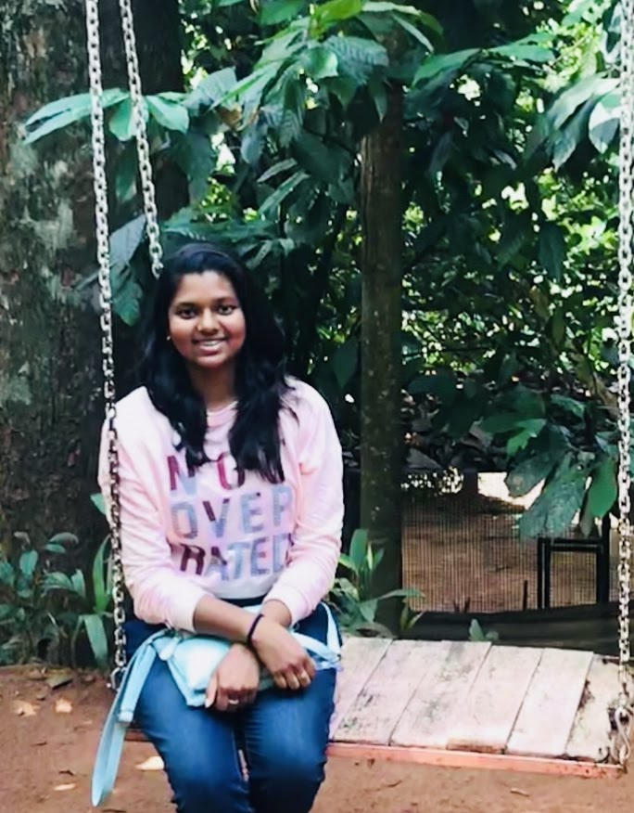

|  |
| --- |
| ambativaishnavi5@gmail.com |
| www.linkedin.com/in/ambati-vaishnavi |
| <https://github.com/Vaishnavi-ambati> |
| https://public.tableau.com/profile/vaishnavi20 |
| www.mywebsite.com |
| 8106308042 |

**CONTACT**

Have gained good exposure to understand various aspects of Machine Learning and Artificial Intelligence through the certification which has developed a great sense of confidence at a very personal level. Hence, I seek a technically challenging position in the area of artificial intelligence and machine learning where I can share my skills and expand my capabilities further in the pursuit of progressive career advancement.

• Big Data Analytics

• Predictive/Statistical Modelling

• Data Mining

• Data Visualization

• Machine Learning Algorithms

• Computer Vision

• Natural Language Processing

• Deep Learning

• Data Wrangling

**Infosys Limited Pune, IN**

**System Engineer**

**Dec '18 - Mar '20**

**Data Collection & Web Scraping**

* Conducted extensive research on billing analytics in the telecommunication sector
* Automated web-pages of client for billing orders by performing **web scraping in Python**.

**Data Wrangling & Visualization**

* Cleaned, merged and manipulated datasets using **Pandas**
* Created various charts in **Jupyter Notebook** using **Matplotlib** to perform a preliminary analysis on the collected data.
* Weekly prepared **MIS reports** for clients which has the analysis of transactions occurred by automation.

**EXPERIENCE**

**SreeNidhi Institute of Science and Technology**

**B. Tech - Electronics and Communication**

**2014 - 2018**

Percentage: 74%

**EDUCATION**

**KEY SKILLS**

**Vaishnavi Ambati**

* PGP - Artificial Intelligence & Machine Learning - NIT Warangal | May '20
* Amazon Certification
* Python Certification

**CERTIFICATIONS**

**INTERNSHIP**

**TECHNICAL SKILLS**

* **Tools**: Python, MySQL, AWS, MongoDB, Spark, Tableau, Excel, R programming.
* **Packages**: Scikit-Learn, NumPy, SciPy, Pandas, NLTK, Beautiful Soup, Matplotlib, Stats models, SpaCy

**Infosys Limited Mysuru, IN**

**System Engineer Trainee**

**Aug '18 - Nov '18**

**Front-end Development**

* Created a graphical interface, through the use of **HTML, CSS, and JavaScript**, so that users can view and interact with that data for Courier Services.

Used Flask for **Development server** and **debugger**

**Back-end Development**

* Created Database schema for Courier Services which connects web to a database, manages user connections, and powers the web application using **MySQL scripts.**
* Developed various functionalities using **Stored Procedures** and **Functions** in MySQL.

**TECHNICAL SKILLS**

**Predicting Cab bookings**

Objective: Used supervised models to predict the total cab bookings in an hour. Also used Ensemble learning for better predictions.

Skills Used: Supervised Learning, Regression and Ensemble Models, Pandas, Matplotlib.

GitHub: <https://github.com/Vaishnavi-ambati/Cab-bookings-project>

**Back-order Prediction**

Objective: To predict whether an order will be a back-order or not for a company.

Skills Used: Supervised Learning, Classification and Ensemble Models, Pandas, Matplotlib.

GitHub: <https://github.com/Vaishnavi-ambati/Cab-bookings-project>

**Restaurant Rating Prediction**

Objective: To predict the rating of a restaurant using various other features.

Skills Used: Supervised Learning and Ensemble Models, Pandas, Matplotlib.

GitHub: <https://github.com/Vaishnavi-ambati/Cab-bookings-project>

**Interactive dictionary**

Objective: A python code which is interactive that is it corrects the spelling if it is wrong.

Skills Used: Python.

GitHub: <https://github.com/Vaishnavi-ambati/Cab-bookings-project>

**PROJECTS**